

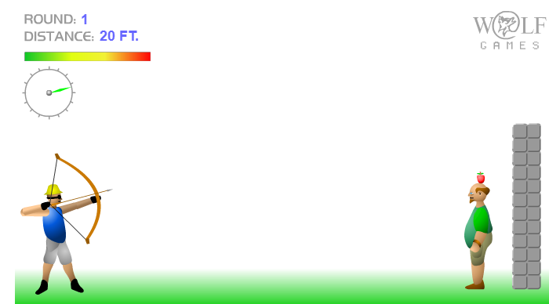

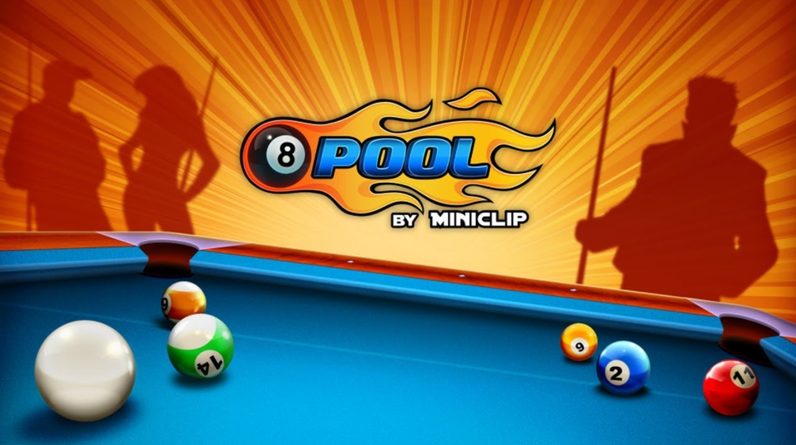

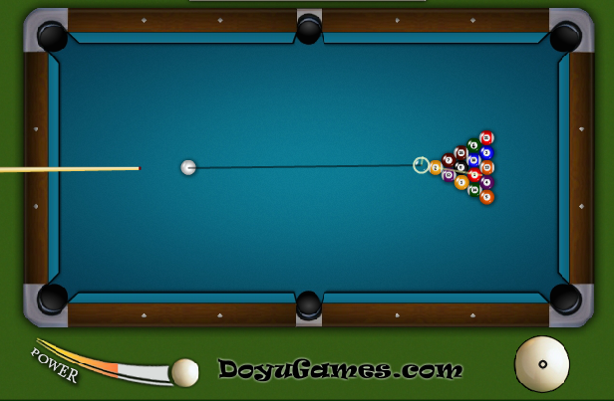

Our main game idea is recreating the “apple shooter” game for the mobile, for local multiplayer.

We first thought of a way to only use the screen tapping as the only user input in order to make a game which anybody could casually play and enjoy in their spare time, but would be more difficult to master, as that would require practice. The first tap would lock the bow’s position, making it unable to repeat its continuous up and down movement. The second tap would stop the power bar from increasing or decreasing, followed by shooting an arrow where the bow is aimed and with the current power.

Next, we thought of a way to make the game playable as a local multiplayer one, and we decided that the best course to take would be to allow each player to shoot once, and then the other player would take over and try to hit the apple. This pattern would be repeated for an ‘X’ number of times before the game would end and each player’s score would be shown on screen.

Our main source of inspiration is the “apple shooter” 2D game in which the player must shoot the apple on top of an NPC’s head without harming it or missing. Also, an interesting addition to this would be a trajectory which would, more or less, display the movement course of the arrow, impacted by the direction, power and gravity. This could be inspired by a game with similar mechanics – 8 Ball Pool – in which the player must line the cue with the ball he wants to hit, choose how much power to apply to the shot, pay attention to where the ball could end up being by following the trajectory closely and then hit the ball with the cue in order to score as many points as possible. The next turn, the other player would try to do the same.